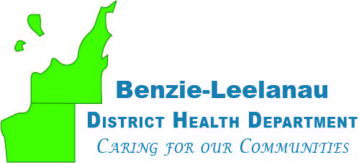
www.bldhd.org

Leelanau County
Personal Health Office
7401 E. Duck Lake Rd
Lake Leelanau, MI 49653
Phone: 231-256-0200
Fax: 231-882-0143

Leelanau County Environmental Health Office
8527 E. Government Center Dr. Suite LL-007
Suttons Bay, MI 49682
Phone: 231-256-0201
Fax: 231-256-0225
Benzie County Office
6051 Frankfort Hwy, Ste 100
Benzonia, MI 49616
Phone: 231-882-4409
Fax: 231-882-0143

Personal Health Director – Full-Time (1.0 FTE)
The Personal Health Director provides leadership, strategic direction, and operational oversight for the Agency's Personal Health Division. Working collaboratively across Agency divisions and with community, regional, and state partners, this position guides programs and services that improve community health outcomes and advance the Agency's mission.
Position Summary
The Personal Health Director is responsible for leading division operations through strategic planning, program oversight, staff development, fiscal management, and community partnership. This role ensures programs and services align with Agency priorities to promote wellness, prevent disease, provide quality health care, address the needs of vulnerable populations, and improve community health.
Essential Functions
- Provide leadership, vision, and strategic direction for the Personal Health Division.
- Lead planning, implementation, monitoring, and evaluation of programs and services to support Agency goals and community health priorities.
- Assess community and individual health needs and use data to guide program development and decision-making.
- Develop and manage division budgets and resources.
- Supervise and support staff through effective personnel management, mentoring, performance management, and professional development.
- Collaborate with Agency leadership, community organizations, and regional and state partners to strengthen programs and services.
- Support policy development, advocacy efforts, and initiatives that advance public health priorities.
- Utilize the Agency strategic plan to guide objectives and organizational decision-making.
- Demonstrate and promote the Agency's core values, including health equity, accessibility, collaboration, and service excellence.
Required Qualifications
- Excellent written, verbal, and interpersonal communication skills.
- Minimum of five (5) years of progressively responsible experience in public health, health programs, community health, or related fields.
- Minimum of three (3) years of leadership, supervisory, or management experience.
- Demonstrated ability to lead teams, manage programs and budgets, and work collaboratively with diverse stakeholders.
Preferred Qualifications
Experience with:
- Public health or community program administration
- Personnel supervision and management
- Budget development and fiscal management
- Policy development and analysis
- Governmental structures, public systems, and community partnerships
Education
Master's degree in public health, health administration, nursing, social work, public administration, or a related field preferred.
Equivalent combinations of education, training, and progressively responsible leadership experience that demonstrate the knowledge, skills, and abilities necessary to successfully perform the position will be considered.
Wage and Benefits
Starting salary is $85,464
Highly competitive benefit package: Health Care, vision, dental, life insurance, STD & LTD insurances
Paid vacation and sick time, 12 paid Holidays
MERS retirement
Anticipated Timeline
Job posting will be open until June 29, 2026
Interviews will be scheduled for mid-July
The position start date will be November 30, 2026

